



Essay / Assignment Title: Database Design for Healthcare System

Programme title:

Name:

Year:

CONTENTS

LIST OF FIGURES IV
INTRODUCTION 1
Background 1
Objective 1
Learning Outcomes 1
Scope 1
CHAPTER ONE: DATABASE DESIGN 3
ER 3
Table Descriptions 4
1. Patients 4
2. Doctors 4
3. Appointments 5
4. MedicalRecords 5
5. Medications 6
6. Prescriptions 6
CHAPTER TWO: DATABASE DESIGN IMPLEMENTATION 8
Creating the Database 8
Creating Tables 8
CHAPTER THREE: DATA INSERTION 12
Sample Data 12
A. Inserting Sample Data into the Patients Table 12
B. Inserting Sample Data into the Doctors Table 13
C. Inserting Sample Data into the Appointments Table 13
D. Inserting Sample Data into the MedicalRecords Table 14
E. Inserting Sample Data into the Medications Table 14
F. Inserting Sample Data into the Prescriptions Table 15
Verification 15
A. Verify Data in the Patients Table 16
B. Verify Data in the Doctors Table 16
C. Verify Data in the Appointments Table 17
D. Verify Data in the MedicalRecords Table 17
E. Verify Data in the Medications Table 18
F. Verify Data in the Prescriptions Table 18
CHAPTER FOUR: DATA RETRIEVAL 20
Upcoming Appointments 20
Patients by Medication 21
Doctors and Specialties 21
CHAPTER FIVE: BUSINESS ANALYTICS QUERIES 23
Average Appointments per Doctor 23
Top 3 Prescribed Medications 23
Monthly New Patients Report 24
CONCLUDING REMARKS 26
Summary 26
Future Work 26
Reflection 26
BIBLIOGRAPHY 28

LIST OF FIGURES

Figure 1: ERD of tables and their relationships in the HealthcareDB database 3
Figure 2: Creating the HealthcareDB Database in MYSQL Workbench 8
Figure 3: Creating the Patients Table in MYSQL Workbench 9
Figure 4: SQL Command to Define the Doctors Table Structure 9
Figure 5: SQL Command to Define the Appointments Table Structure 9
Figure 6: SQL Command to Define the MedicalRecords Table Structure 10
Figure 7: SQL Command to Define the Medications Table Structure 10
Figure 8: SQL Command to Define the Prescriptions Table Structure 10
Figure 9: MYSQL Workbench data insertion to Patient table 12
Figure 10: MYSQL Workbench data insertion to Doctors table 13
Figure 11: MYSQL Workbench data insertion to Appointments table 13
Figure 12: MYSQL Workbench data insertion to Medical Records table 14
Figure 13: MYSQL Workbench data insertion to Medications table 14
Figure 14: MYSQL Workbench data insertion to Prescriptions table 15
Figure 15: Data availability verification on Patients table using MYSQL Workbench 16
Figure 16: Data availability verification on Doctors table using MYSQL Workbench 16
Figure 17: Data availability verification on Appointments table using MYSQL Workbench 17
Figure 18: Data availability verification on MedicalRecords table using MYSQL Workbench 17
Figure 19: Data availability verification on Medications table using MYSQL Workbench 18
Figure 20: Data availability verification on Prescriptions table using MYSQL Workbench 18
Figure 21: MYSQL Workbench query listing all appointments for the upcoming week 20
Figure 22: MYSQL Workbench query of records of all the patients prescribed a certain medication 21
Figure 23: MYSQL Workbench query listing all doctors along with their specialties. 22
Figure 24: MYSQL Workbench query to get Average Appointments per Doctor 23
Figure 25: MYSQL Workbench query to determine the top 3 most commonly prescribed medications 24
Figure 26: MYSQL Workbench query to generate a monthly report of the number of new patients added over the past year 25

Statement of compliance with academic ethics and the avoidance of plagiarism
I honestly declare that this dissertation is entirely my own work and none of its part has been copied from printed or electronic sources, translated from foreign sources and reproduced from essays of other researchers or students. Wherever I have been based on ideas or other people texts I clearly declare it through the good use of references following academic ethics.
(In the case that is proved that part of the essay does not constitute an original work, but a copy of an already published essay or from another source, the student will be expelled permanently from the postgraduate program).

Name and Surname (Capital letters):

.......................................................................................................................................

Date: ........................./........../.........

INTRODUCTION

Background
In the context of the contemporary healthcare sphere, the need for proper data organization has become a determining factor to provide adequate client services and organizational effectiveness (Osipov and Skryl, 2021). With a massive amount of patients’ data, medical records, appointments, and prescriptions, the database management should be strong and capable of handling a large number of entries. These systems must enable the storage, retrieve and analyzing of health care data in a way that effectively supports the clinicians’ working processes (Shafqat et al., 2020), minimizes the burden of paperwork and helps improve patients’ quality of life.

Objective
The scope of this project is to develop a healthcare database and organize its functioning with the help of MySQL (Misal et al., 2022). The database will serve the storage and retrieval archiving, as well as the functions of a healthcare establishing with efficiency. The purpose of this applied task is to improve the intern’s working knowledge of how to design a simple relational DB, add realistic values, and use complex MySQL queries for business intelligence in the sphere of healthcare (Gangadevi and BU).

Learning Outcomes
1. Learn the meaning of the terms such as databases and database management systems, as well as the main principles and methods of the database design, administration, and management.
2. Know the basics of query data, tools, and methods applied in business analysis, and perform query techniques to get data from MySQL.
3. Perform complex queries on databases using a sophisticated SQL code to transform, clean, and analyze data sets.

Scope
This report will cover the following tasks:
1. Database and Tables Creation: Setting up the data base for the Healthcare DB project and defining the suitable tables along with the keys and formats.
2. Data Insertion: Creating tables, these which contain some sample data in a realistic type and writing simple select-statements.
3. Business Analytics Queries: Formulating the syntax of complex queries to manipulate the data and generate useful information for managerial decision-making in the sphere of healthcare.

CHAPTER ONE: DATABASE DESIGN

The HealthcareDB database is proposed for the management of data at the healthcare facility in the most efficient manner. This database will allow for the storage and organization of patient and doctor details, appointments, account numbers, records, prescription details and medication data (Okemiri et al., 2020). This makes it possible to provide accurate, accessible and easily accessible information for clinical decision-making, ease administrative burden and at the same time provide quality care to patient’s increased organizational efficiency. The entities in HealthcareDB are designed in a relational manner, which means that it is easy to determine the associations between different entities and the relationships between them, and hence, can be used to achieve the managerial and business goals of the healthcare system.
ER Diagram
ER stands for Entity-Relationship (Shin, 2022) and the diagram shown below is an illustration of tables as well as their relationships in the HealthcareDB, which is a database. This diagram is useful for explaining how tables work together through their primary and foreign keys.
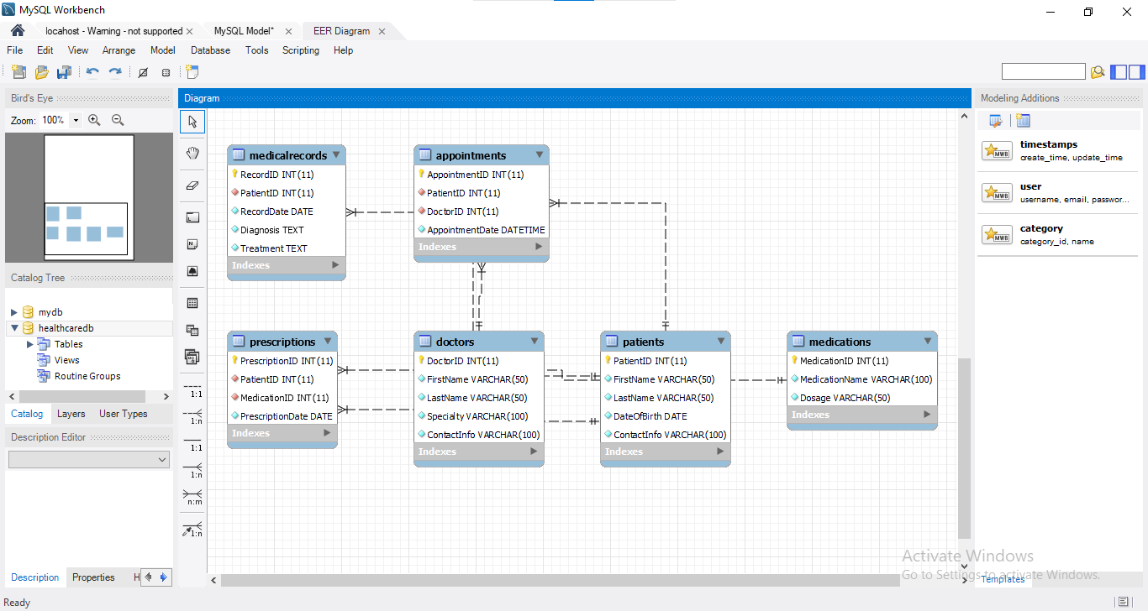
Figure 1: ERD of tables and their relationships in the HealthcareDB database
The tables and their interconnection in the HealthcareDB database are illustrated with the help of the ER (Entity-Relationship) diagram. This diagram aids in figuring out how one entity (table) is related to another through the use of primary and foreign keys.

Table Descriptions

1. Patients
Description: This table keeps the identification data of the patients.
Significance: It thus makes it easy to consolidate information regarding individual patients, and locate information about any particular patient. This table is very useful for a database that will connect patients, their details, appointments, medical history and prescriptions.
Columns:
`PatientID`: BIGSERIAL, Primary Key, NOT NULL
`FirstName`: VARCHAR (50), NOT NULL
`LastName`: VARCHAR(50), NOT NULL
`DateOfBirth`: DATE, NOT NULL
`ContactInfo`: VARCHAR(100), NOT NULL UNIQUE

2. Doctors
Description: This table has fields to store all the minor physical characteristics of the doctors.
Significance: It aids in the management of doctor information such as their specialty and information on how to get to them. This particular table is highly important for an appointment calendar and linking patients’ records and prescriptions to a particular doctor.
Columns:
`DoctorID`: BIGSERIAL, Primary Key, NOT NULL
`FirstName`: VARCHAR(50), NOT NULL
`LastName`: VARCHAR(50), NOT NULL
`Specialty`: VARCHAR(100), Not Null
`ContactInfo`: VARCHAR(100), No Null

3. Appointments
Description: This table keeps track of the sessions that are due between the patients and the doctors.
Significance: appointment calendar It helps in time management of appointments, and it connects a patient to the attending physician. It is useful in the proper coordination of the relationships between patients and the physicians that attend to them as well as in the timely scheduling of the appointments.
Columns:
`AppointmentID`: BIGSERIAL, Primary Key, NOT NULL
`PatientID`: INT, Foreign key (References Patients. PatientID), Nullable=False
`DoctorID`: INT, Foreign Key (References Doctors. DoctorID), NOT NULL
`AppointmentDate`: TIMESTAMP, NOT NULL

4. MedicalRecords
Description: This table maintains database records of patient’s health information.
Significance: It can be used in offering a complex picture of a patient’s health history, which is useful in decision making, and care transitions. As far as medical histories are concerned, this table plays a vital role in updating and enriching patients’ files.
Columns:
`RecordID`: BIGSERIAL, Primary Key, NOT NULL
`PatientID`: BIGSERIAL, Foreign Key (A reference to Patients table. PatientID), NOT NULL
`RecordDate`: DATE, Not Null
`Diagnosis`: TEXT, Not Null
`Treatment`: TEXT, Not Null

5. Medications
Description: This table is used to store details about the medication.
Significance: It has the function of prescription reference of medications given to patients to avoid mistakes in prescriptions. This table is quite useful of relating the prescriptions to certain medications.
Columns:
`MedicationID`: BIGSERIAL, Primary Key, NOT NULL
`MedicationName`: VARCHAR(100), NOT NULL
Dosage: VARCHAR(50), NOT NULL

6. Prescriptions
Description: This table is used to store prescription details of patients that the doctors will be issuing.
Significance: It links prescribes medication to the patients and has one-to-one relationship with the medications table. This table needed for tracking management of the patient’s treatment and using it to give adequate medication to the patient.
Columns:
`PrescriptionID`: BIGSERIAL, Primary Key, NOT NULL
`PatientID`: BIGSERIAL, FOREIGN KEY (REFERENCES Patients. PatientID), NOT NULL
`MedicationID`: BIGSERIAL, FOREIGN KEY (REFERENCES Medications. MedicationID), NOT NULL
`PrescriptionDate`: DATE NOT NULL
All the tables implemented in the HealthcareDB database are very important to provide strong framework for the healthcare administrative needs. This way, the relationships between these tables can provide a complete data integration to perform many administrative and clinical tasks in the healthcare facility.

CHAPTER TWO: DATABASE DESIGN IMPLEMENTATION

In the implementation phase, working with MySQL becomes a crucial activity by which the designed database will be turned into a fully-functional database (Desamsetti, 2020). This invokes the creation of the `HealthcareDB` and defining the required tables that will assist in data organization. Implementation is writing scripts in Structured Query Language to create the tables with desired column and type, as well as the constraints such as primary and foreign keys. These scripts are the impetus for starting and organizing medical data while guaranteeing that the database is ready for accurate and effective data collection and analysis.

Creating the Database
To establish the HealthcareDB database, the following SQL script is used:
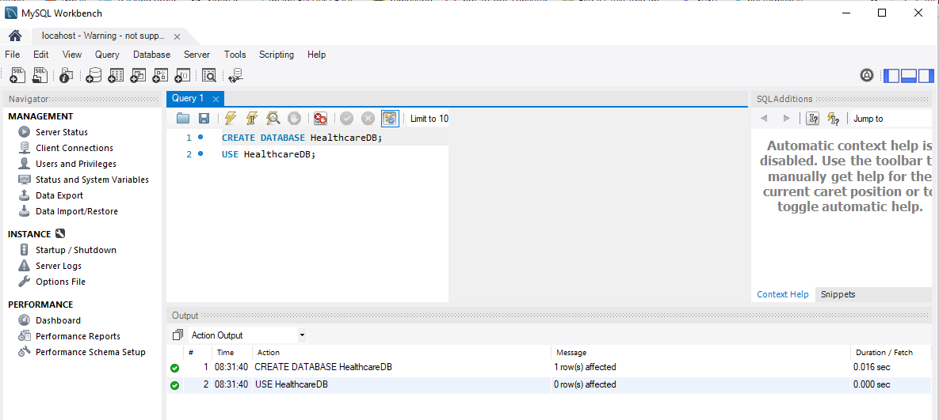
Figure 2: Creating the HealthcareDB Database in MYSQL Workbench

Creating Tables
The subsequent SQL scripts are employed to create each table within the HealthcareDB database:
- Creating the Patients Table
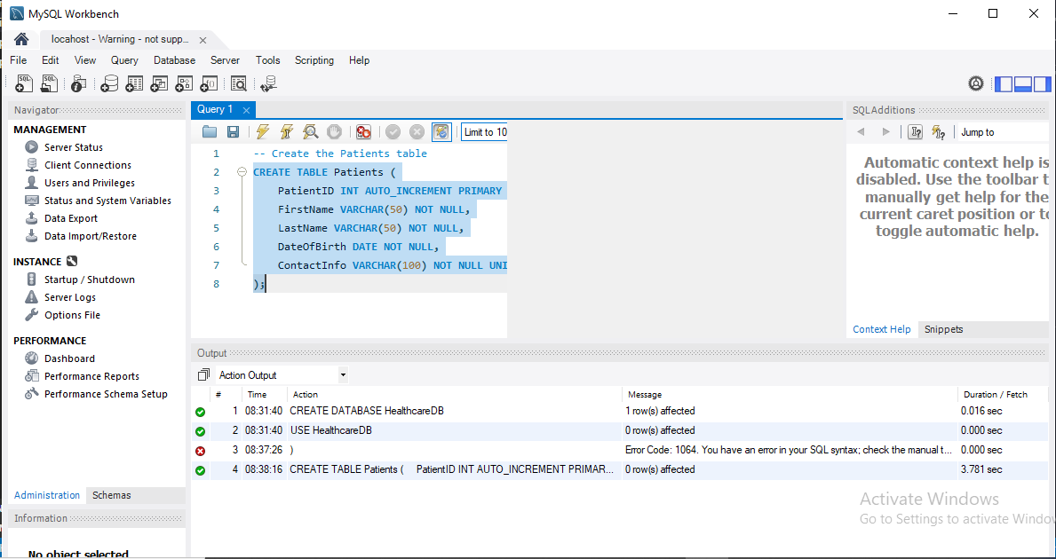
Figure 3: Creating the Patients Table in MYSQL Workbench
- Creating the Doctors Table
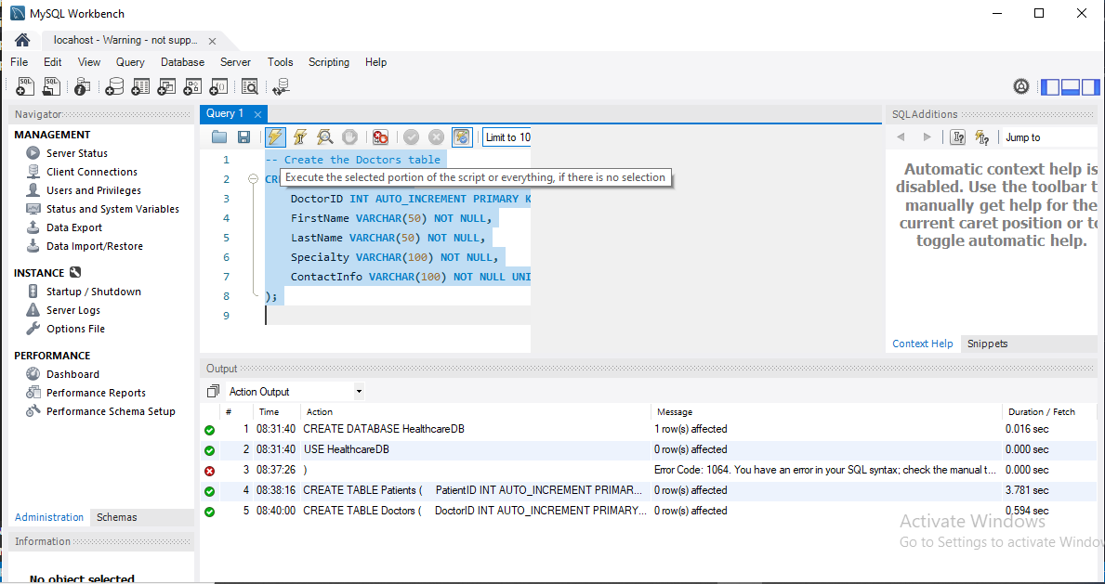
Figure 4: SQL Command to Define the Doctors Table Structure in MYSQL Workbench
- Creating the Appointments Table
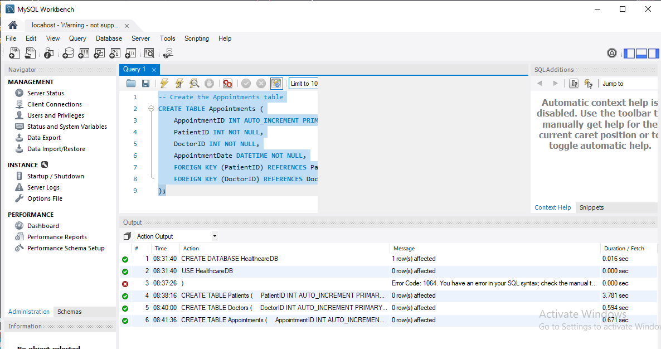
Figure 5: SQL Command to Define the Appointments Table Structure in MYSQL Workbench
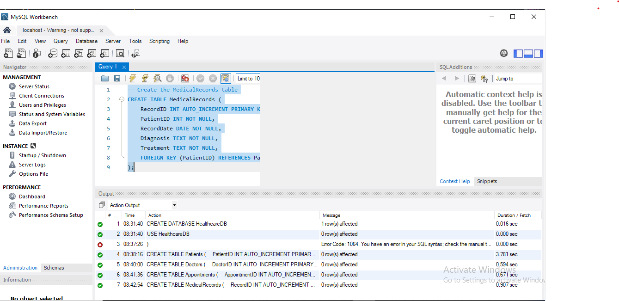
Figure 6: SQL Command to Define the MedicalRecords Table Structure in MYSQL Workbench
- Creating the Medications Table
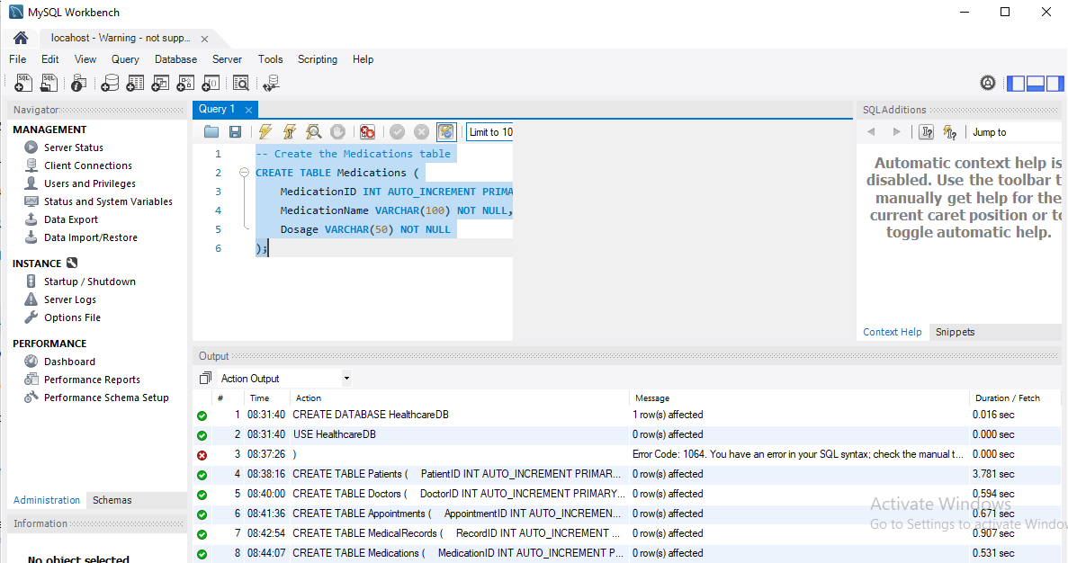
Figure 7: SQL Command to Define the Medications Table Structure in MYSQL Workbench
- Creating the Prescriptions Table
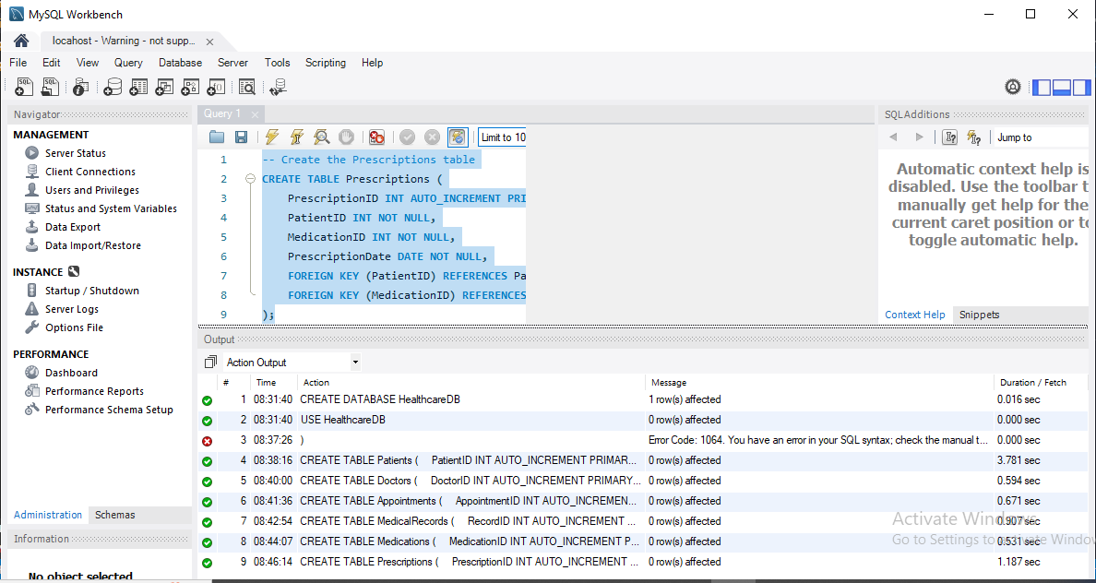
Figure 8: SQL Command to Define the Prescriptions Table Structure in MYSQL Workbench
These scripts create the necessary tables within the `HealthcareDB` database, establishing the required primary and foreign key relationships to ensure data integrity and facilitate efficient data management.

CHAPTER THREE: DATA INSERTION

The data insertion phase concerns the insertion of sample data into the HealthcareDB database to check how useful the chosen database design is for real-life practice. In this step, the use of SQL scripts to initialize the tables with a minimum of 10 records for testing and validation purposes. After the insertion of data, the validity check queries are carried out in order to ensure that the data is properly stored and that the intercommunication between various tables is proper.

Sample Data

Inserting Sample Data into the Patients Table
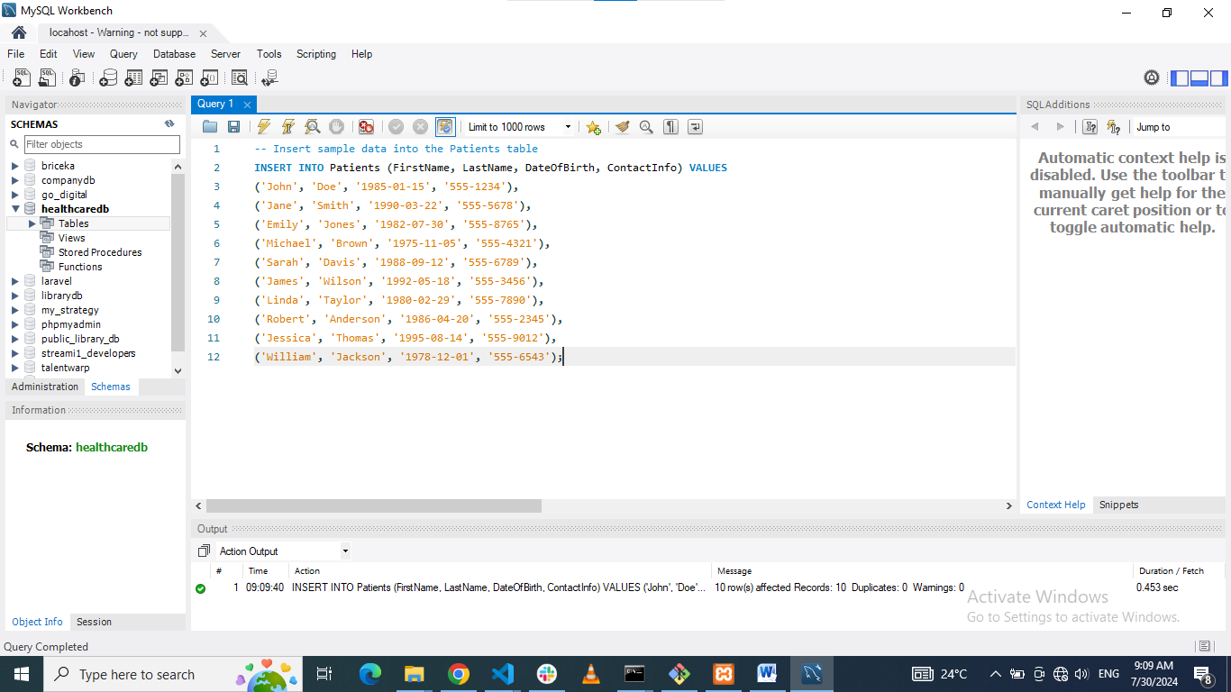
Figure 9: MYSQL Workbench data insertion to Patient table

Inserting Sample Data into the Doctors Table
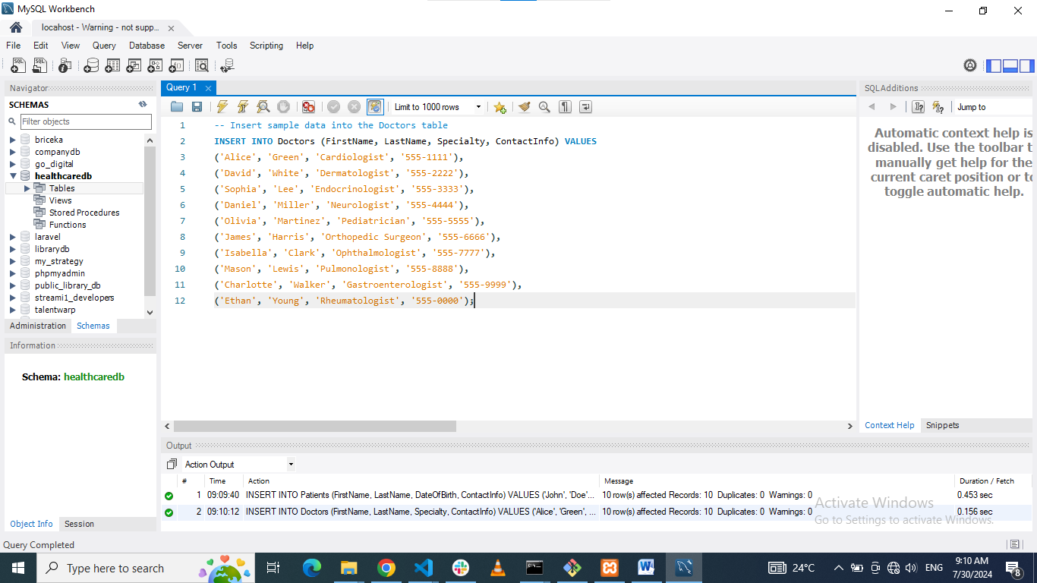
Figure 10: MYSQL Workbench data insertion to Doctors table

Inserting Sample Data into the Appointments Table
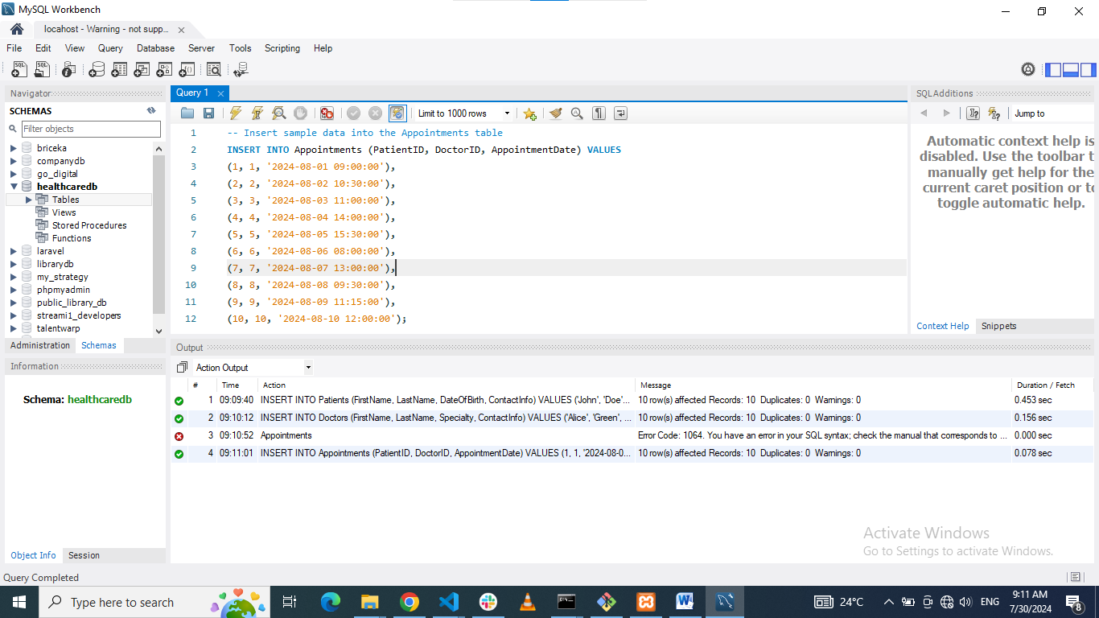
Figure 11: MYSQL Workbench data insertion to Appointments table

Inserting Sample Data into the MedicalRecords Table
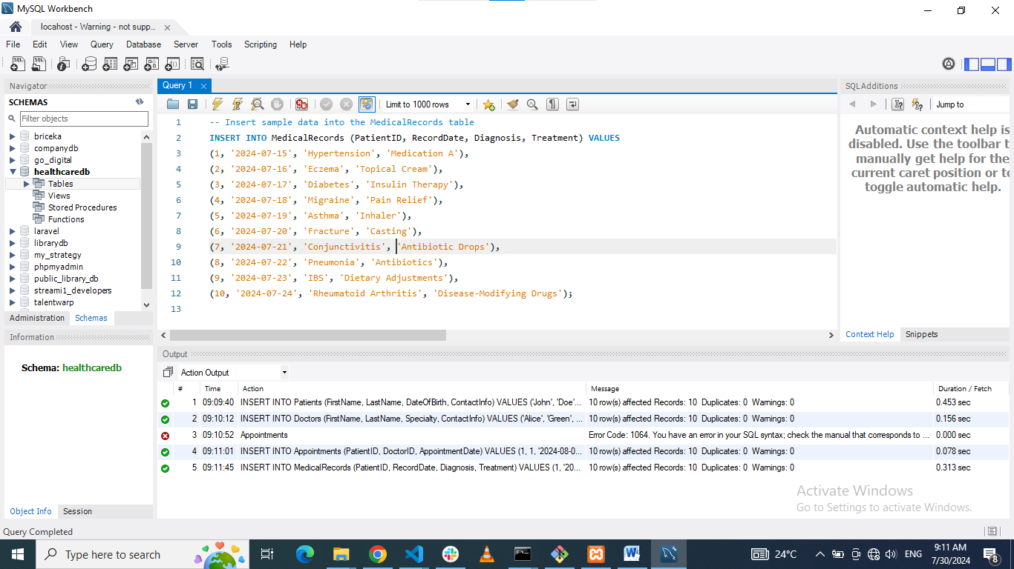
Figure 12: MYSQL Workbench data insertion to Medical Records table

Inserting Sample Data into the Medications Table
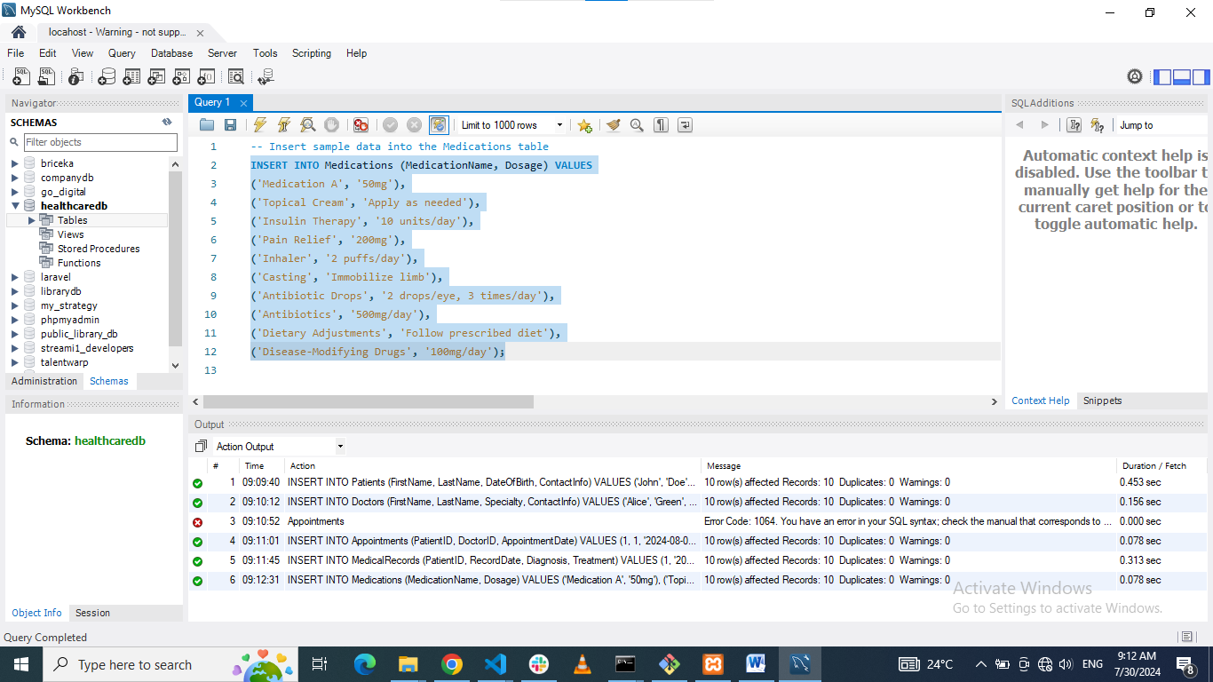
Figure 13: MYSQL Workbench data insertion to Medications table

Inserting Sample Data into the Prescriptions Table
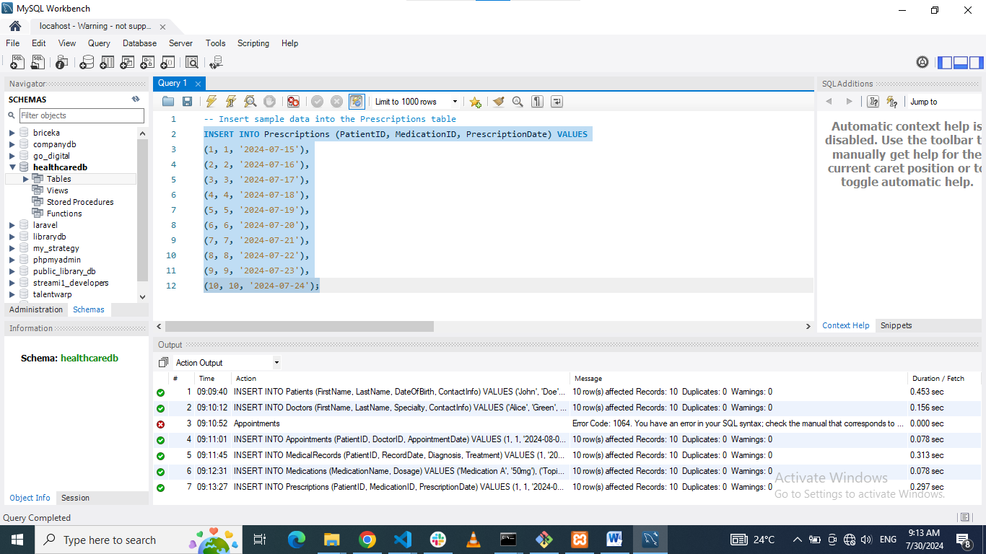
Figure 14: MYSQL Workbench data insertion to Prescriptions table

Verification
To ensure that the data has been correctly inserted, the following queries can be used to verify the contents of each table:

Verify Data in the Patients Table
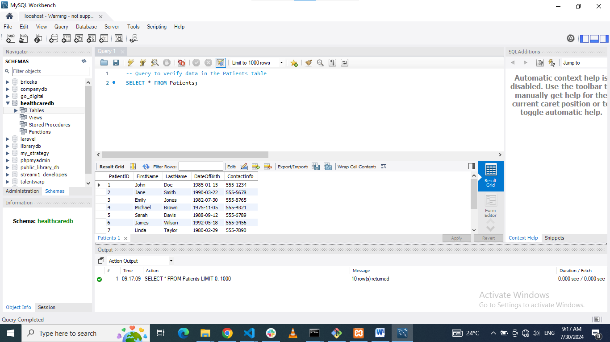
Figure 15: Data availability verification on Patients table using MYSQL Workbench

Verify Data in the Doctors Table
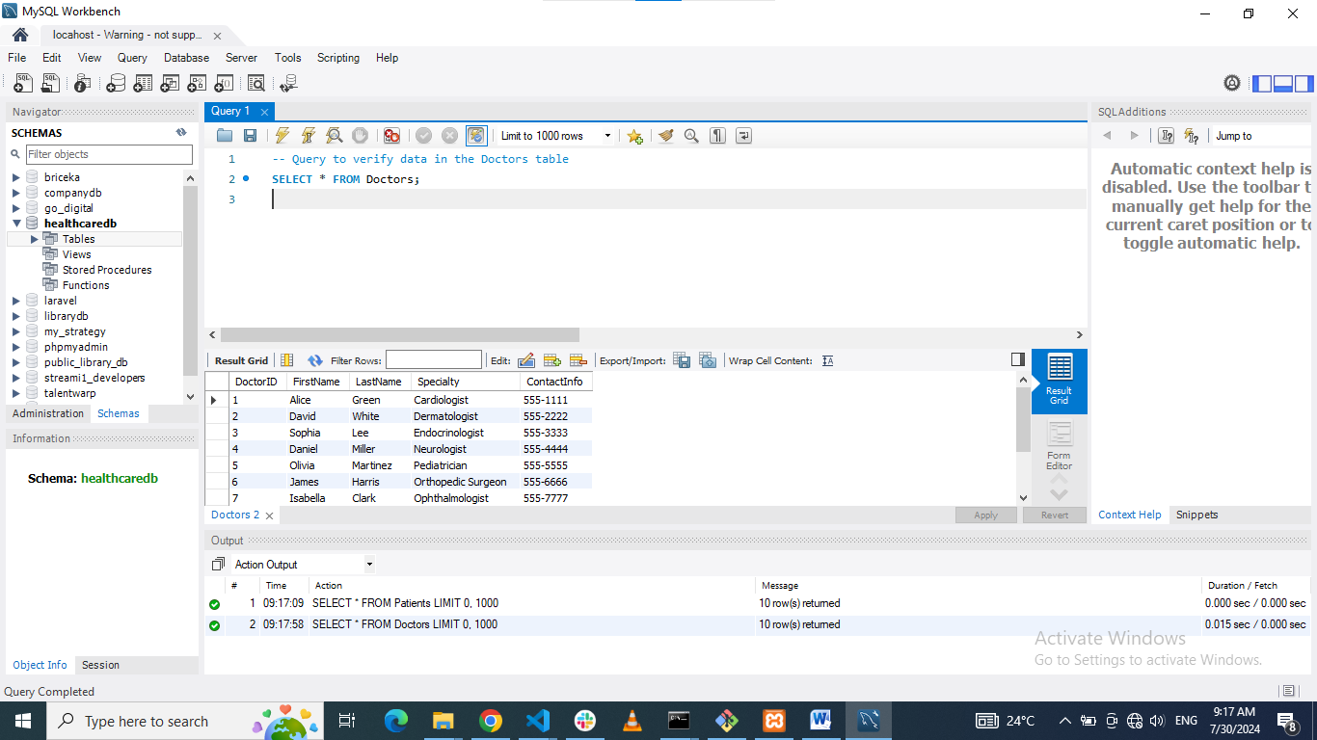
Figure 16: Data availability verification on Doctors table using MYSQL Workbench

Verify Data in the Appointments Table
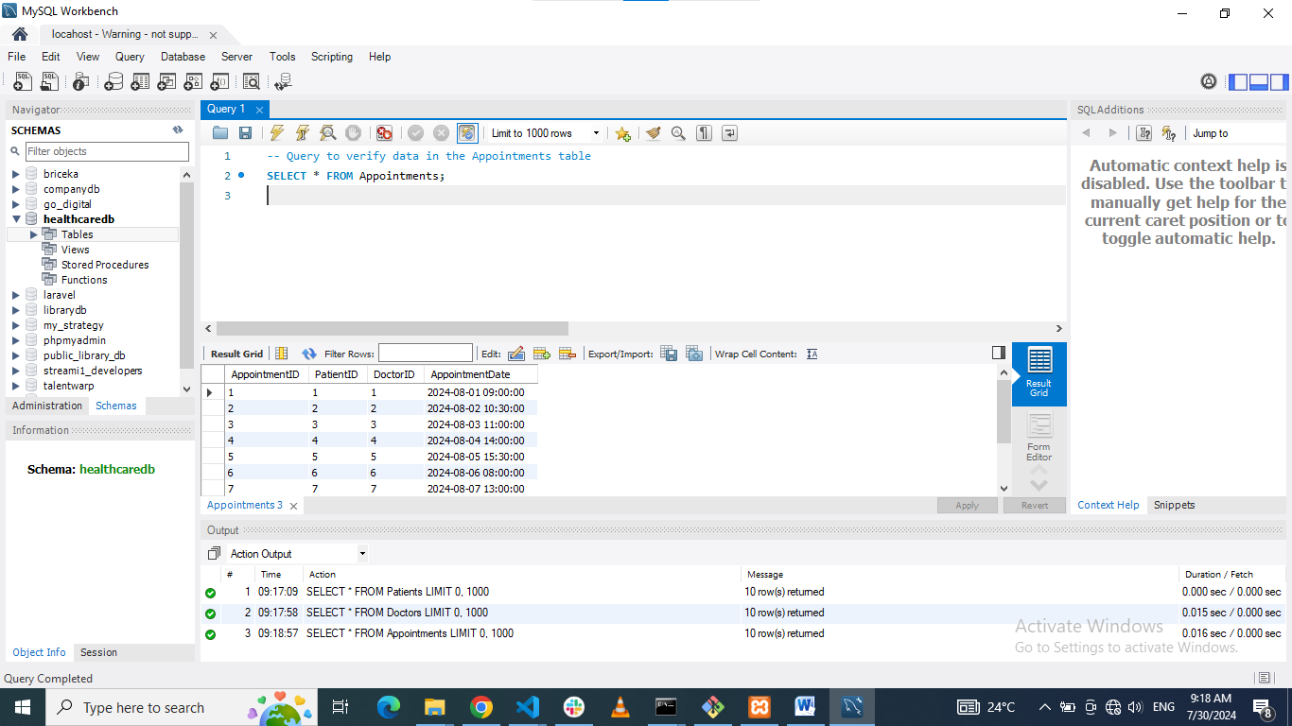
Figure 17: Data availability verification on Appointments table using MYSQL Workbench

Verify Data in the MedicalRecords Table
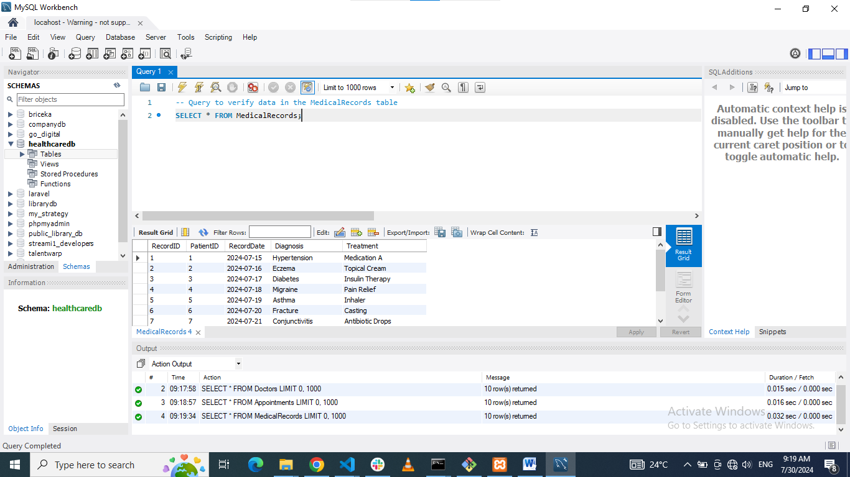
Figure 18: Data availability verification on MedicalRecords table using MYSQL Workbench

Verify Data in the Medications Table
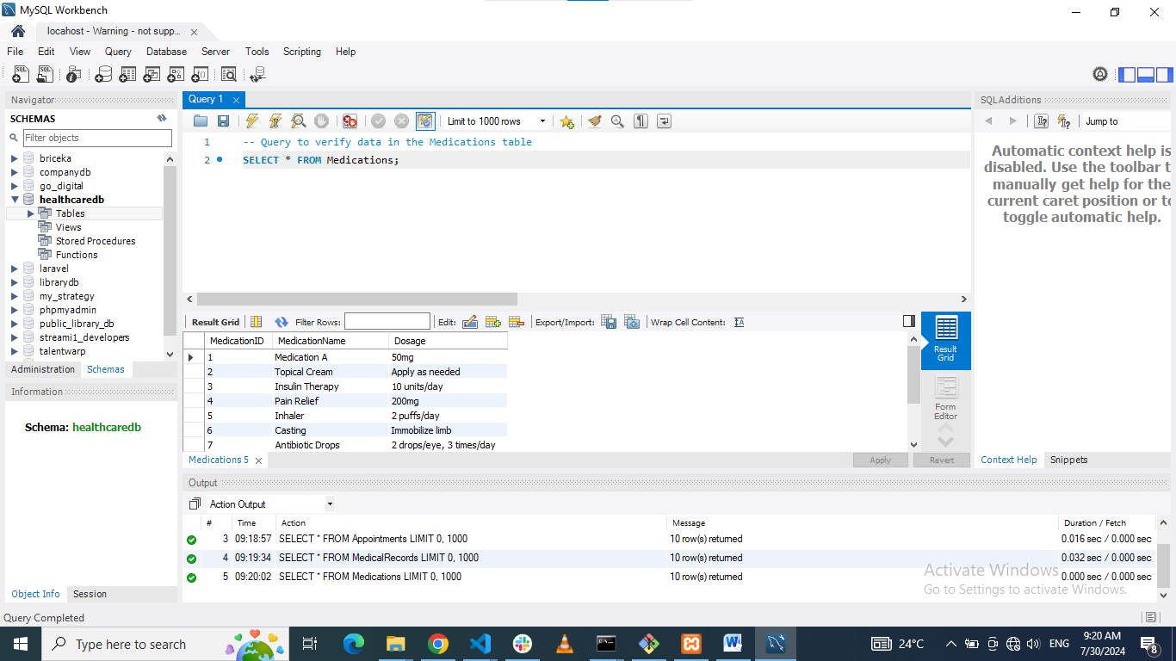
Figure 19: Data availability verification on Medications table using MYSQL Workbench

Verify Data in the Prescriptions Table
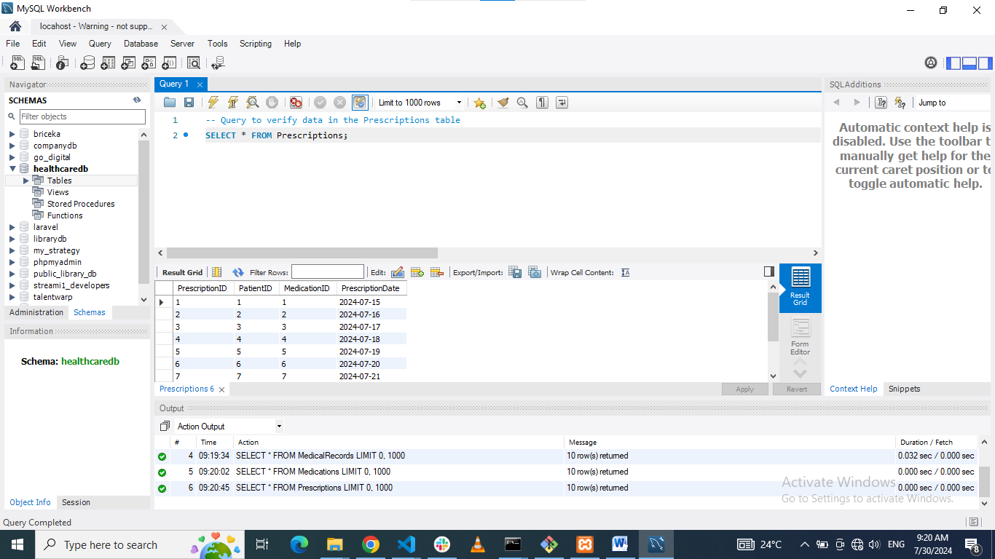
Figure 20: Data availability verification on Prescriptions table using MYSQL Workbench
To ensure that the sample data has been correctly inserted into each table and that the data is ready for analysis and further reporting, the following verification queries will be carried out.

CHAPTER FOUR: DATA RETRIEVAL

The data retrieval phase concentrates on pulling relevant information from the `HealthcareDB’ database, in order to meet both functional and informational requirements of the end users. This entails competency in writing SQL queries to select the information that is needed by the system such as dates of next appointments, patients that have been prescribed specific types of drugs, and details of doctors and other related details. Such queries enable the neat extraction of relevant information and useful results for management of the health care systems.

Upcoming Appointments
To list all appointments for the upcoming week, the following SQL query can be used:
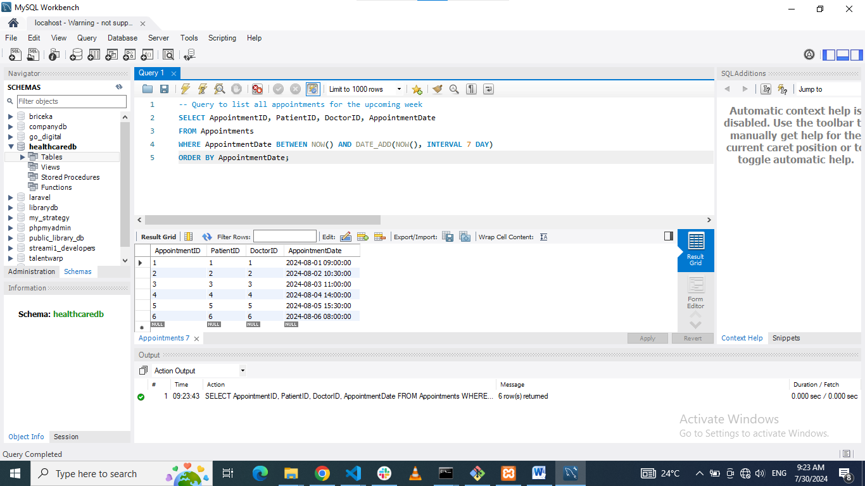
Figure 21: MYSQL Workbench query listing all appointments for the upcoming week
This query gives appointments of the next week so that a user can be able to view and manage the coming patient appointments.

Patients by Medication
The following SQL query can be used to obtain the records of all the patients that were prescribed a certain medication. For this example, the project will use ‘Medication A' as the desired medication name:
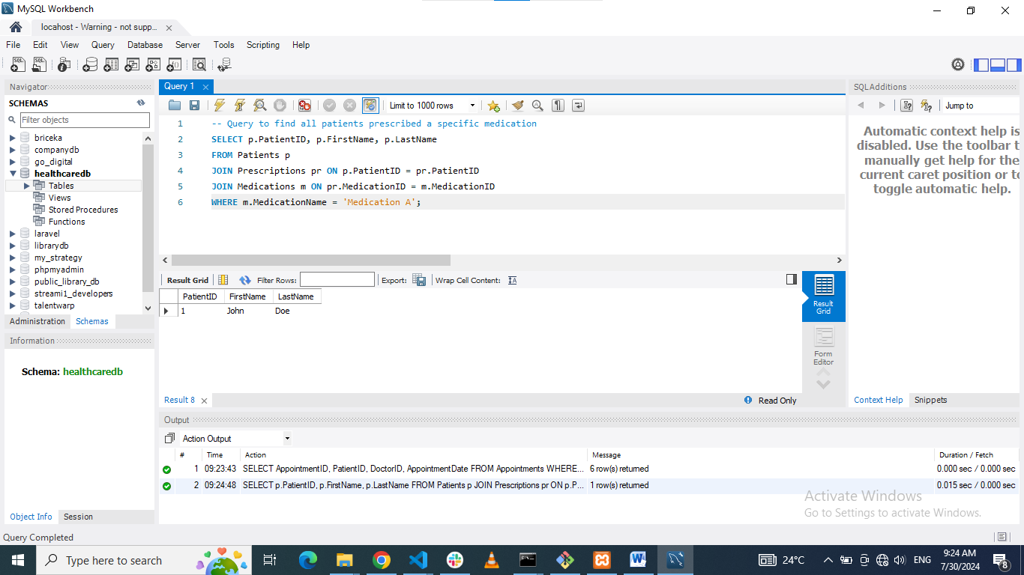
Figure 22: MYSQL Workbench query of records of all the patients prescribed a certain medication
This query connects patients with prescriptions and medications, whereas a particular medication is searched to lists all the patients who have been prescribed to take it.

Doctors and Specialties
To list all doctors along with their specialties, the following SQL query can be used:
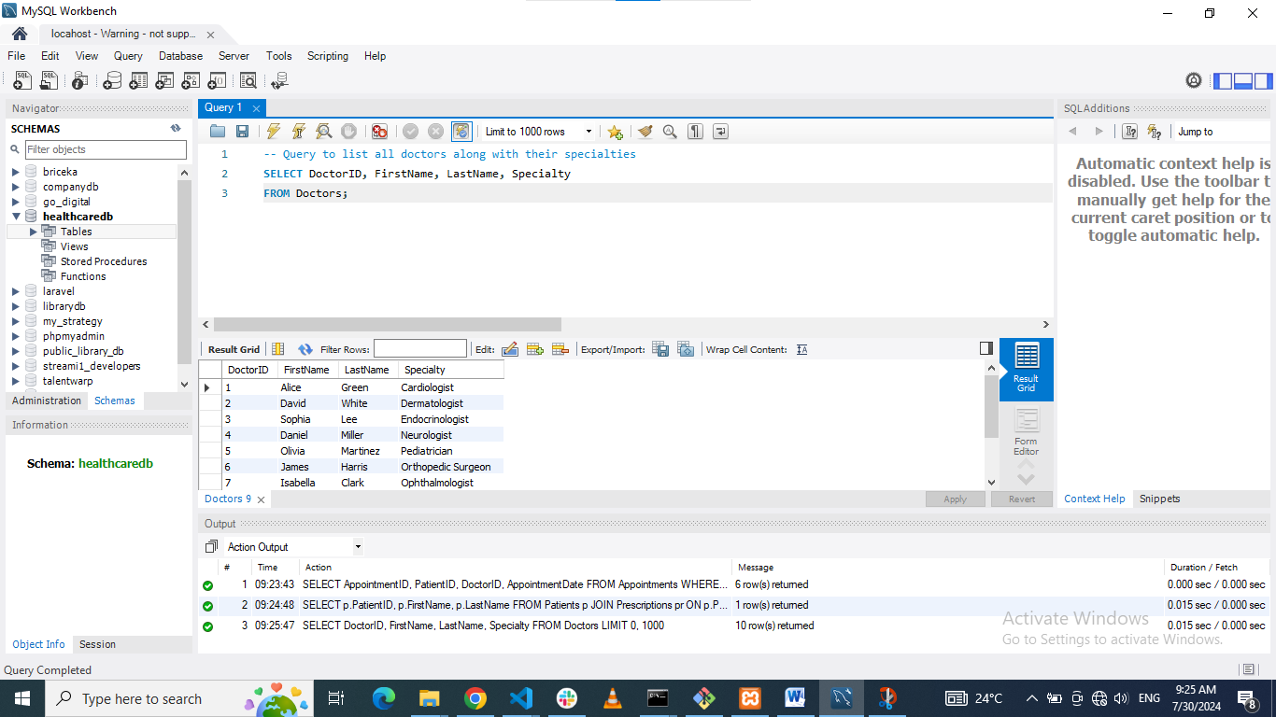
Figure 23: MYSQL Workbench query listing all doctors along with their specialties.
This query fetches the names and the specialty of all the doctors, yields a complete staffing list of the medical staff and areas of practice among the doctors.

CHAPTER FIVE: BUSINESS ANALYTICS QUERIES

The queries carried out in business analytics pertain to the HealthcareDB database to analyze essential data. Such queries assist in appreciating certain indicators like average no. of appointments/doctor, most prescribed drugs, and patient progression among others. By utilizing these queries solid decisions can be made by the health care administrator that enhances the health care systems functionality (Chen, Lin and Wu, 2020).

Average Appointments per Doctor
To calculate the average number of appointments per doctor, the following SQL query is used:
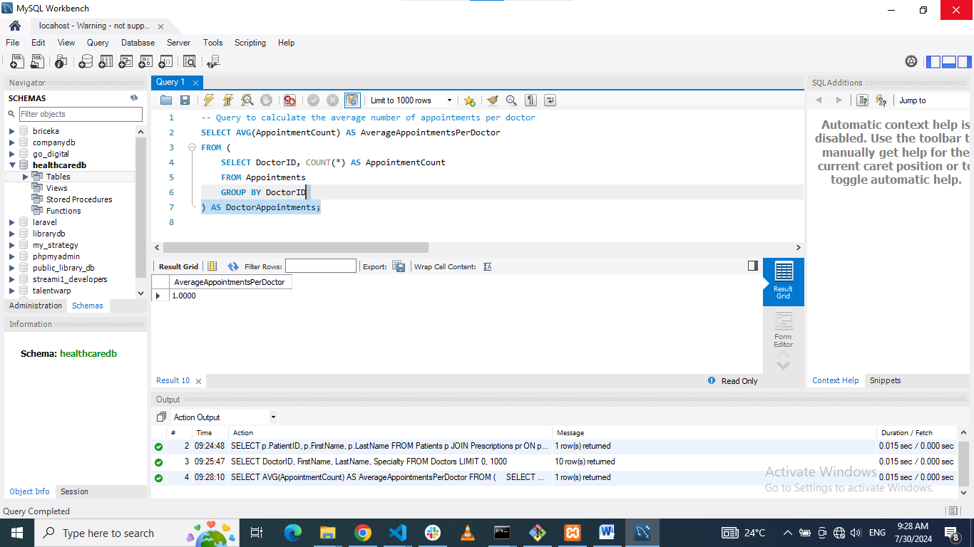
Figure 24: MYSQL Workbench query to get Average Appointments per Doctor
This query initially sums the number of appointments by each doctor and, following that calculation, averages the result.

Top 3 Prescribed Medications
To determine the top 3 most commonly prescribed medications, the following SQL query is used:
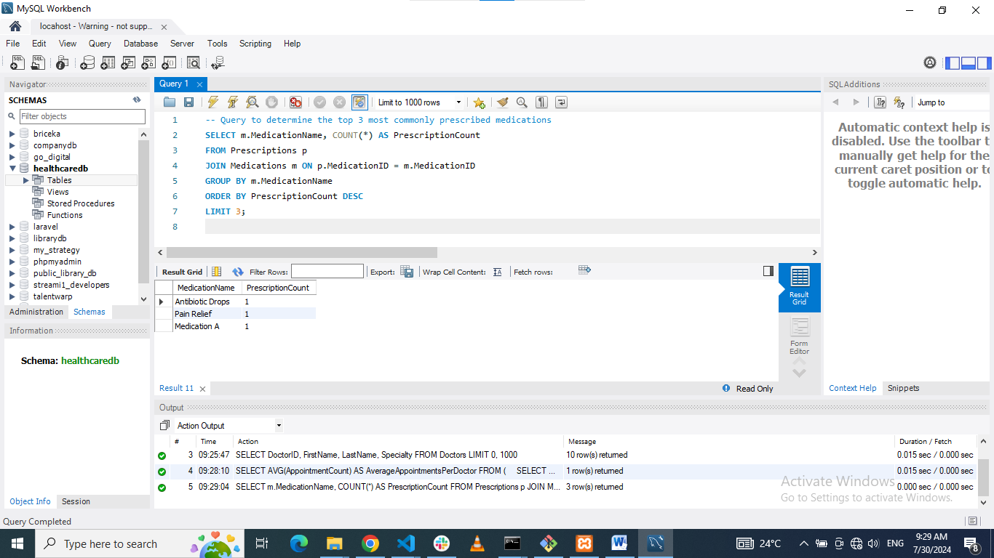
Figure 25: MYSQL Workbench query to determine the top 3 most commonly prescribed medications
This query calculates the number of prescriptions for a given medication and sorts and restricts the result to only three drugs with the highest prescriptions.

Monthly New Patients Report
To generate a monthly report of the number of new patients added over the past year, the following SQL query is used:
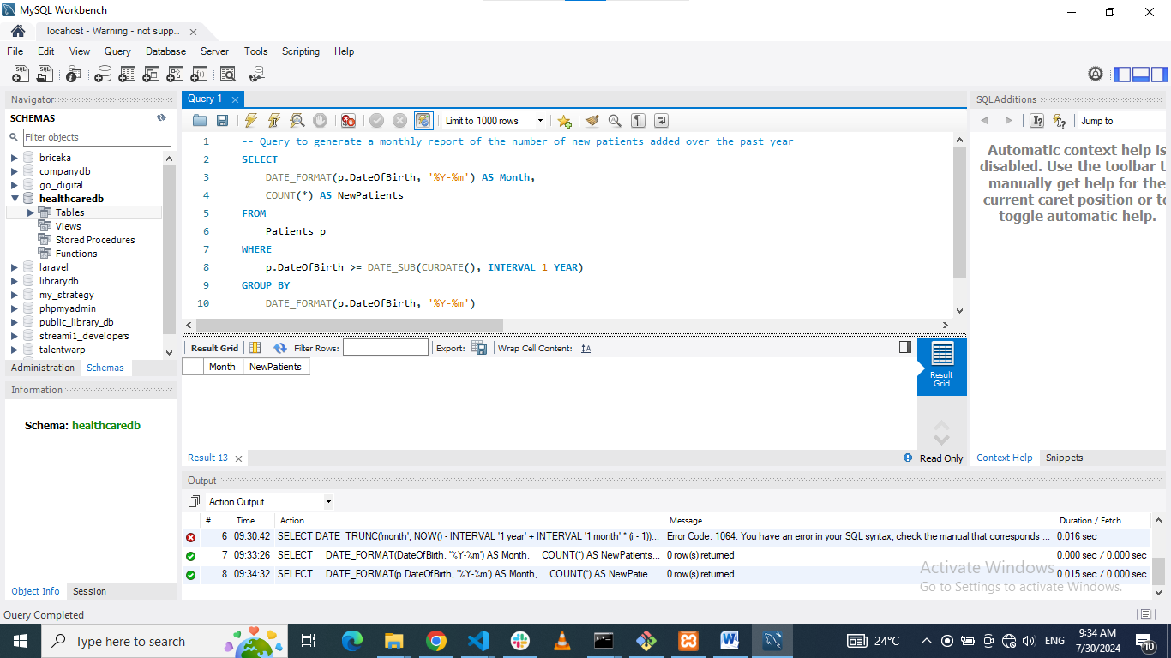
Figure 26: MYSQL Workbench query to generate a monthly report of the number of new patients added over the past year
This query finds the list of all months in the past year and, subsequently, calculates the number of new patients admitted in each month. The generate_series function generates a series of month and dating to the starting of a month, hence the use of the DATE_TRUNC function in the subsequent steps of the query.

CONCLUDING REMARKS

Summary
With the use of the `HealthcareDB` database; there is a proper well-elaborated structure that facilitates the efficient management of healthcare data (Marcos-Pablos, Juanes-Méndez and García-Peñalvo, 2022). The database was created with six core tables: There are `Patients`, `Doctors`, `Appointments`, `MedicalRecords`, `Medications`, and `Prescriptions` tables established, and all of them are as carefully developed as it is possible with adequate primary and foreign keys accurate at every moment. Then, the data was populated with sample dummy records in order to ensure that it worked, and a series of Test Queries that returned information on the next appointments, patient’s medical history regarding medication, and respectively, the specialty of the doctor. Additional queries to business analytics included the average of appointments within the doctor, the most frequently used medication within the center, the three medications that are most frequently prescribed, and the new addition report on the number of patients added within a month over the last year.

Future Work
Possible future advancements to the `HealthcareDB’ could be broadened to encompass more points of consideration about the patient such as his insurance policy, the doctor’s working hours, and treatment efficacy. Another advantage could be expanding the targeted database in order to ensure that it interacts with other health care systems, where data exchange is a critical issue. Applying machine learning and better forecasting of patient prognosis and resource use could be considered as the further steps in the continuation of the work.

Reflection
This project served as an apt opportunity for a practice of the actual designing and implementation of a database in a health care setting (Malm-Nicolaisen, Johansen Fagerlund and Pedersen, 2023). The exercise was useful in showcasing the need to establish efficient and proper structures to organize database for the purpose of analysis. Developing skills of writing SQL statements that would help to extract meaningful information was a powerful encouragement to underline the importance of evidence-based approaches to the health care management. In general, the project deepened the awareness of the structure and use of relational databases, as well as SQL as a language, which is necessary for the subsequent activities in the field of database management and analysis.

BIBLIOGRAPHY

Osipov, V.S. and Skryl, T.V., 2021. Impact of digital technologies on the efficiency of healthcare delivery. In IoT in Healthcare and Ambient Assisted Living (pp. 243-261). Singapore: Springer Singapore.
Shafqat, S., Kishwer, S., Rasool, R.U., Qadir, J., Amjad, T. and Ahmad, H.F., 2020. Big data analytics enhanced healthcare systems: a review. The Journal of Supercomputing, 76, pp.1754-1799.
Misal, R.G., Sanaafrin, M.R., Bagade, L.B., Gadade, M.R. and Sayyad, S.S., 2022. Advanced Hospital Management System. Int J Res Appl Sci Eng Technol, 10(6).
Gangadevi, M.D. and BU, C., BIG DATA ANALYSIS AND CLOUD IN THE APPLICATIONS OF HEALTHCARE.
Okemiri, H., Alo Uzoma, R., Achi, I., Oketa, C., Nnamene, C. and Chima, C., 2020. Patient Data Integration: a panacea for effective healthcare. Journal of Computer Science, 16(2), pp.235-248.
Shin, S.S., 2022. Teaching Method for Entity–Relationship Models Based on Semantic Network Theory. IEEE Access, 10, pp.94908-94923.
Desamsetti, H., 2020. Relational Database Management Systems in Business and Organization Strategies. Global Disclosure of Economics and Business, 9(2), pp.151-162.
Chen, P.T., Lin, C.L. and Wu, W.N., 2020. Big data management in healthcare: Adoption challenges and implications. International Journal of Information Management, 53, p.102078.
Marcos-Pablos, S., Juanes-Méndez, J.A. and García-Peñalvo, F.J., 2022. The Role of Data in Health Sciences Ecosystems: Experiences Within a Psychoeducation-Oriented IT Platform. In Technological Adoption and Trends in Health Sciences Teaching, Learning, and Practice (pp. 283-299). IGI Global.
Malm-Nicolaisen, K., Johansen Fagerlund, A. and Pedersen, R., 2023. Exploring the emergence of open platforms in healthcare: Design considerations and experiences from an initial case in Norwegian primary care.

